Methodist Learning Center
at First United Methodist Church of Port St. Joe, Florida

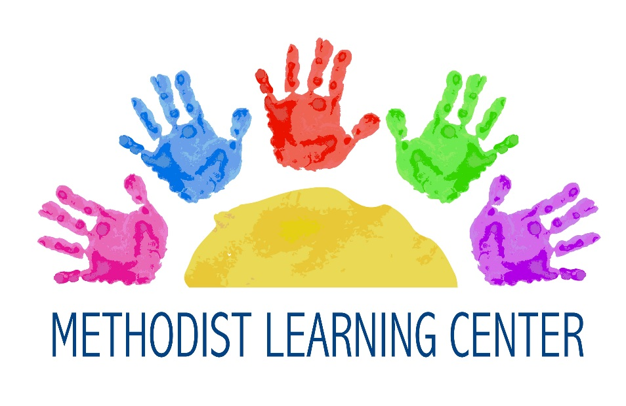

Preschool Program
License # C14GU0717
Parent Handbook
Courtney Knox, MLC Director
1001 Constitution Drive
Port St. Joe, Florida 32456
850-227-1724 (church office)
courtney@psjumc.org (email)

TABLE OF CONTENTS
History and Philosophy……………………...……………….….......…...1 Religious Education……………………………………..........…………...1 Enrollment/Registration……………………………............…………….2 Tuition………………………………………………..……………........….2 Late Fees………………………………………………....………………...3 Staff Training…………………………………………….....……………..3 Drop Off and Pick Up Procedures……………………….................…...3 Discipline………………………………………………....………………..4Health……………………………………………………..………………..5 Influenza Virus. 5
Safety/Emergency Situations…………………………..............………...8 Medications…………………………………………………. 9
Birthday and Special Events……………………………..............…......10
Clothing and Toys………………………………………......…………...10
Snack, Lunch and Nutrition……………………………................…….10
Parental Involvement and Volunteers……………….................……...11

HISTORY AND PHILOSOPHY

The Methodist Learning Center is a ministry of the First United Methodist Church.

The central purpose of the program is to develop good self-esteem and individual personal qualities within each child, while offering the highest possible educational techniques through hands-on, developmentally appropriate activities. The program’s curriculum will provide a comprehensive program for each child. The staff, who is very creative, energetic, nurturing and educated about child development, implements the curriculum. Social, physical, cognitive, and emotional areas of growth are fostered through interesting experiences in the program’s setting. Positive reinforcement and guidance in learning activities and play foster each child’s self-esteem. We believe that our program should be based on the use of play as a tool in learning basic concepts.

The curriculum is planned with monthly themes and will provide
music, chapel, movement, art, language, and monthly special events that are age appropriate.

RELIGIOUS EDUCATION

The Methodist Learning Center is a Christian preschool. We believe that each child is a unique gift from God, and therefore worthy of love, acceptance and support. We offer a weekly Chapel program for two, three and four year olds. Religion is integrated into our program by way of stories, song, art and many other forms. We start every morning with Assembly, which includes the Pledge of Allegiance and The Lord’s Prayer.

ENROLLMENT/REGISTRATION

Enrollment is open to all children, 6 weeks through four years of age for our preschool, and children attending elementary school for our school age program, regardless of religion, race, sex, or creed. The number of spaces available in each class determines acceptance. The birthday cut-off date for all classes is September 1.

Current immunization record and physical must be on file by the first week of attendance for preschool children. These forms can be obtained from your pediatrician’s office. The Program enforces this policy with direction from the Department of Children and Families. Shot records and physical must be kept up to date; if they have expired your child will not be able to return to school until we receive a current form.

TUITION

The fee schedule is outlined in the Schedule of Payments form. Our full day preschool program is a full year program. Tuition is for the year, but can be paid in monthly increments. Your agreement to pay tuition is not subject to adjustment because of illness, or absence of the child. Withdrawal of your child does not relinquish the Tuition payments are due the first (1st) of every month and are delinquent after the fifth (5th) of the month, at which time a late fee of $25 will be added to your total. Tuition payments made after the tenth (10th) of the month will have an additional $50 late fee applied. Tuition not paid by the end of the month will forfeit your child’s spot in the program. If there is any difficulty in reaching this deadline, please notify MLC Director immediately. Be advised that two returned checks will result in a denial of acceptance of any further payment by check. All payments need to be made in check or money order form. Payments made by mail must be received by the deadline and not just postmarked by the first. All fees are governed by the MLC Committee and subject to change. responsibility of payments for the year your child is registered for.

SCHOOL AGE SUMMER CAMP- “CAMP JOE”
Summer camp for school age students is offered Monday-Friday, 7:15-5:30pm. Our summer camp program is offered in two sessions, Summer A and/or Summer B. Tuition is due at time of enrollment in summer camp session A or B. Weekly field trips are offered to the school age students participating in Camp Joe. You are required to pay for field trip fees during the entire session you have enrolled in. If your child is absent for any reason you will not be reimbursed for not attending the field trip.

LATE FEE

Our hours of operation are 7:15 a.m. until 5:30 p.m. Your account is assessed our late fee of $5.00 starting at 5:35pm if your child has not been signed out. An additional late fee of $1 per minute per child will be charged starting at 5:36pm. If habitual tardiness continues, we reserve the right to dismiss your child from the program.

STAFF TRAINING

Training requirements for all our staff are listed below:
40-hour childcare training course 10 hours of annual training Infant/Child CPR training annually Employment references Local Criminal Background Check Federal Background check.

DROP OFF AND PICK UP PROCEDURES

The state requires all children to be signed in when they are dropped off and signed out when they are picked up. All person’s signing in and out must be 18 years or older. Keep in mind your child must be dropped off in the care of a Methodist Learning Center staff member only. All students must be dropped off by 9:00am if they are planning to come to school that day. When your child’s class is participating in any other activity outside of their classroom you must still escort them to the designated area to be dropped off with a staff member.

DISCIPLINE

Discipline is the process of encouraging children to learn self- control and to avoid danger to self or others. An important aspect of discipline is the development of an environment, which is carefully planned to prevent problems by having low adult/child ratios, child proofing in every area, providing adequate toys and materials, channeling behavior in acceptable ways and planning developmentally appropriate activities and routines. Occasionally, all children feel uncooperative and should be allowed time and a space to gain their self-control. Children experiencing difficulty will be gently removed from an over stimulating situation and be given a place to sit within eyesight of the teacher. When difficult situations arise, teachers encourage children to examine what has happened and help work out possible solutions. If this move proves to be unsuccessful the child will then be brought to the director’s office to talk things out. If the child continues to struggle within the classroom after all measures have been exhausted, he/she will be asked to leave the program.

BITING - Biting is very common in young children. It is a way for your child to express themselves when they cannot do this verbally. The teachers try and make every effort to keep biting children away from the other children to prevent any more incidences. If a young child has bitten 3 times in a day our young friend may need to take a break from their other friends and be asked to stay home as determine by the director. Older children will be asked to be picked up on a case to case circumstance.

HEALTH
The State of Florida requires every child who attends our program to have a physical examination completed by a licensed physician stating that the child is in good health and all immunizations are up to date. The following forms must be on file with the Methodist Children’s Academy office within fourteen days of attendance:

1. Florida Physical Exam Yellow Form DH#3040
2. Florida Immunization Blue Card DH#680- Part B

The immunization card must be updated each time your child receives an immunization. It is your responsibility to bring the blue card you received while at the doctor’s office to the Methodist Learning Center office. You must keep this card up to date. Physicals must be updated every two years. Notices will be sent home if your records are not current. Your child will not be able to attend if either card has expired, regardless of a scheduled doctor’s appointment.

Please do not send sick children to school. If your child has run a fever, had diarrhea, or vomited in the last 24 hours, they are not well enough to come to school and should not return the next day. If your child does not feel well enough to participate in all activities (outside play, movement, etc.) please let them stay home until they can participate. If your child becomes ill while in our care, (fever, has had more than 2 diarrheas, or vomited) you will be contacted immediately. Every effort will be made to contact you first, then your emergency contact person. If your child is sent home sick, he/she may not return to school the next day. Please Note: The Health Department can supersede all of our policies if deemed necessary.

If your child should be injured while in our care, however slight, our staff will fill out an accident report, which we will ask you to sign before you leave. If an accident indicates a need for immediate attention, every effort will be made to locate the parent and the child will be transported to the hospital of the parent’s choice or to the nearest hospital, whichever is deemed necessary. When a child is sick, a parent or guardian will be called immediately. Your child will need to be picked up within 30 minutes of notification. Methodist Children’s Academy may apply fees to the accounts of children that are sick and are not picked up in a timely manner.

INFLUENZA VIRUS - THE FLU, A GUIDE TO PARENTS

What is the influenza (flu) virus?
Influenza (“the flu”) is caused by a virus which infects the nose, throat, and lungs. According to the US Center for Disease Control and Prevention (CDC), the flu is more dangerous than the common cold for children. Unlike the common cold, the flu can cause severe illness and life threatening complications in many people. Children under 5 who have the flu commonly need medical care. Severe flu complications are most common in children younger than 2 years old. Flu season can begin as early as October and last as late as May.

How can I tell if my child has a cold, or the flu?
Most people with the flu feel tired and have fever, headache, dry cough, sore throat, runny or stuffy nose, and sore muscles. Some people, especially children, may also have stomach problems and diarrhea. Because the flu and colds have similar symptoms, it can be difficult to tell the difference between them based on symptoms alone. In general, the flu is worse than the common cold, and symptoms such as fever, body aches, extreme tiredness, and dry cough are more common and intense. People with colds are more likely to have a runny or stuffy nose. Colds generally do not result in serious health problems, such as pneumonia, bacterial infections, or hospitalizations.

What should I do if my child gets sick?
Consult your doctor and make sure your child gets plenty of rest and drinks a lot of fluids. Never give aspirin or medicine that has aspirin in it to children or teenagers who may have the flu.

Call or take your child to a doctor right away if your child:
• Has a high fever or fever that lasts a long time
• Has trouble breathing or breathes fast
• Has skin that looks blue
• Is not drinking enough
• Seems confused, will not wake up, does not want to be held, or has seizures (uncontrolled shaking)
• Gets better but then worse again
• Has other conditions (like heart or lung disease, diabetes)
How can I protect my child from the flu?
A flu vaccine is the best way to protect against the flu. Because the flu virus changes year to year, annual vaccination against the flu is recommended. The CDC recommends that all children from the ages of 6 months up to their 19th birthday receive a flu vaccine every fall or winter (children receiving a vaccine for the first time require two doses). You also can protect your child by receiving a flu vaccine yourself.

What can I do to prevent the spread of germs?
The main way that the flu spreads is in respiratory droplets from coughing and sneezing. This can happen when droplets from a cough or sneeze of an infected person are propelled through the air and infect someone nearby. Though much less frequent, the flu may also spread through indirect contact with contaminated hands and articles soiled with nose and throat secretions.

To prevent the spread of germs:
• Wash hands often with soap and water.
• Cover mouth/nose during coughs and sneezes. If you don’t have a tissue, cough or sneeze into your upper sleeve, not your hands.
• Limit contact with people who show signs of illness.
• Keep hands away from the face. Germs are often spread when a person touches something that is contaminated with germs and then touches his or her eyes, nose, or mouth.

When should my child stay home from child care?
A person may be contagious and able to spread the virus from 1 day before showing symptoms to up to 5 days after getting sick. The time frame could be longer in children and in people who don’t fight disease well (people with weakened immune systems). When sick, your child should stay at home to rest and to avoid giving the flu to other children and should not return to child care or other group setting until his or her temperature has been normal and has been sign and symptom free for a period of 24 hours.

For additional helpful information about the dangers of the flu and how to protect your child, visit: http://www.cdc.gov/flu/ or http://www. immunizeflorida.org/

SAFETY/EMERGENCY SITUATIONS

The personal safety of each child is our most important consideration. Only persons authorized on the emergency cards may pick up your child. You may add or delete names on your list by sending a written notice or requesting a change to the office. We request that you call the center if someone other than the regular person is picking up your child. Please inform all new pick-up people that they will need to show proof of identification before the child will be released to them. Children will not be released to older siblings unless they are high school age.

Fire drills are held on a monthly basis to acquaint children and staff with evacuation procedures. Our center is equipped with fire alarms and smoke detectors throughout our building.

If a state of emergency is declared by the Gulf County Emergency Management or the weather is deteriorating and warnings have been issued by the weather bureau and people have been asked to stay off the roads, then the church staff in conjunction with the program director may make a decision about closures. We will weigh all factors involved before making our decision. This is for your safety and the safety of the children.

Methodist Learning Center follows the Gulf County School System closing of schools in emergency situations. There may also be times we need to close the center due to adverse weather conditions. Listen to local radio station or local television stations for more information about the closing of schools.

MEDICATIONS

All medications, prescription and non-prescription, must be in its original container. Prescription medication may be dispensed to the child that has their name on the label of the medication. All non- prescription medications must be age-appropriate. A medication form must be filled out for all prescription and non-prescription medicines. Medications should be handed to a teacher and not left in a lunch box or back pack.

BIRTHDAYS AND SPECIAL EVENTS

Birthdays are important and the program gives each birthday child special attention. Parents may send a special treat for the whole class if they wish. Please contact your child’s teacher to discuss appropriate birthday treats.

CLOTHING AND TOYS

We play outside every day, weather permitting, so please dress your child in appropriate play clothes. Children need to dress comfortably for the weather and the day’s activities. In their exploration of their surroundings, the children will get dirty. We will take precautions to prevent their clothes from being soiled, such as using paint smocks, as we can, but we will not discourage the children’s imaginations or creativity.

Please bring an extra change of clothes for your child including socks and shoes. Label all personal items that are brought to the center. This should include all cups, lunch boxes, back packs, and all and clothing. It has been mandated by the state that all sippy cups be labeled with both first and last name.

SNACK, LUNCH AND NUTRITION

The program provides a snack for all children every morning and afternoon. Please let us know of any allergies that your child has to any foods. Some of the snacks are coordinated with the monthly curriculum and theme. Please provide a boxed lunch for your child each day with an ice pack or thermos if necessary. If you need assistance with what to send in your child’s lunch box, please ask the teachers for ideas.

PARENTAL INVOLVEMENT AND VOLUNTEERS

Because we recognize the value of the involvement of those dedicated to the enrichment of the children, it is very important to us to welcome and utilize the talents of parents, grandparents, and significant others in as many areas of the program as possible.

Volunteers help the school meet the needs of the children by sharing time and talents and making the program more flexible and thus, more child-oriented through increased personal attention and assistance. Volunteers are welcome in the areas of storytelling, special events, holidays and many other ways. We encourage the interaction of parents and grandparents with their child in preschool. If you would like to volunteer in the program, please let us know. There is a special place for you!

